1-What is the truth table of this gate?

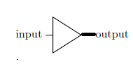

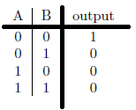 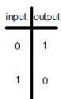 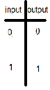 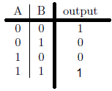

a b c d e?

2-This Truth table belongs to which gates?

 a-Nor b-Nand c-Xor d-And e?

3- This Truth table belongs to which gates?

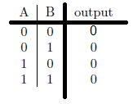 a-Nor b-Nand c-Xor d-And e?

4- This Truth table belongs to which gates?

 a-Nor b-Nand c-Xor d-And e?

5- Which ones have the same outputs?

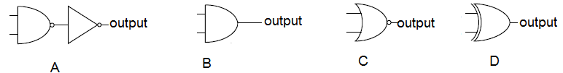

1-A and B 2-A and C 3-B and D 4 4-B and C 5?

6-- Which ones have the same outputs?

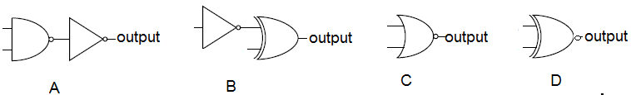

1-A and B 2-A and C 3-B and D 4 4-B and C 5?

7-Which one is wrong?

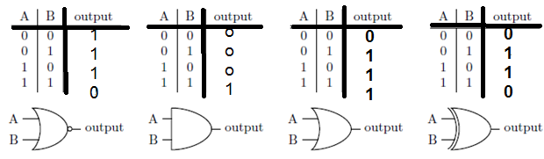

1 2 3 4

a-1 b-2 c-3 d-4 5-?

8-How can we design a NOT gate using NAND gate?

9- How can we make an AND gate Using NAND gate?

10- How can we make a NOR gate Using NAND gate?

11- Which one is a NOT gate?

1-X 2-Y 3-Both 4-Non 5-?

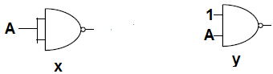

12- Which one is a NOT gate?

1- X 2-Y 3-Both 4-Non 5-?

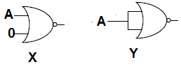

13- What is ab’+a’b ?

a-Nor b-Nand c-Xor d-And e?

- What is (a’b’+ab)’?

a-Nor b-Nand c-Xor d-And e?

14- This truth table belongs to “Full Adder”?

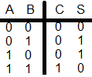

1-Yes 2-No

15- This truth table belongs to “Full Adder”?

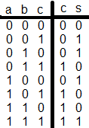

16 -Can we add 2 numbers using ripple Adders??

1-Yes 2-No